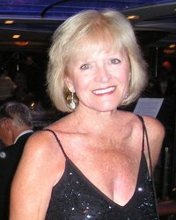

“Fighting Back”

Offers a recipe for fighting back against a deadly, incurable disease - that’s what the doctors call it - incurable.

My recipe is simple:

A big heart
+
A fighting spirit
+
A strong support group
+
Prayer
=
Victory

Please Pray for Me,

I need your help!

What is Victory?

How should we define victory?

Is it living forever?

Rosann defines Victory like this:

Heroes and Villains

“There are so many heroes that I cannot begin to thank you all enough for helping me Fight Back. I especially want to thank;

1. Each person that sent flowers, cards, telephoned or visited me at the hospital; it meant a lot to me; I feel your love;

3. SSM Health Care Center in O’Fallon, Mo. and all the Doctors, Nurses and staff that saved my life and helped me recover from the operation;

4. SSM Rehabilitation Center for helping me get started with my Fight;

6. Tampa Bay Cancer Center radiation oncologist Janelle Park, M.D. and her staff - they were wonderful;

7. University Community Hospital Outpatient Rehabilitation - specifically therapists Cara Bryan and Kevin Bobos.

8. My son, Dave, for helping me fly back to Tampa and, well, for being my son. I love you;

9. My Art Group in Tampa, especially my friend and teacher Kathi Hobbs;

10. My Golf Group; Brenda, Carol, Barb, Lee, Vi and many others;

11. My Notre Dame High School classmates many of whom sent me cards and offered payers;

12. My Beta Sigma Phi Sorority sisters; we were just starting to have fun!

13. My special friend Lillian Stickle, who would do anything for me, and has;

14. My husband, Jim. He didn’t bargain for this, but never flinched. I love you lots;

15. Every one of you that prayed for me; you are the true heroes. Keep it up!!!!!

Villains

There are no villains, just disappointing actions. I truly believe there is good in all of us. However, there were several notable disappointments.

1. Gloom and Doom Doctors

2. Doctors that don’t treat their patients with dignity!

3. Insurance Plans that provide you a Bill of Rights and list of resources that you are entitled to, and then foster roadblocks that bar you from accessing theses resources.

“It’s been two months since I was diagnosed with lung cancer. Why have I not received any treatment? Who is responsible?”

About This Book

This is a story about a courageous woman who is Fighting Back against long odds. On March 5th, 2011 Rosann Plautz was blindsided by a terrible disease. Twenty eight hours after attending her 50th high school reunion, she underwent an emergency craniotomy to relieve pressure from blood accumulating in her brain. There was little warning.

Rosann survived the operation but the news was not good.

- There are three metastatic tumors in your brain;

- There is a large mass of tissue in the lung, it’s inoperable;

- The diagnosis is Adenocarcinoma of the lung;

Oh, and by the way, you are 900 miles from home and, can’t fly for 10 days.”

Is that all? Are you through?

Did I forget to tell you that your lack of vision is permanent? You are legally blind. The lack of vision will make Rehab difficult.

These are the cards that Rosann was dealt. This story is about how she plays these cards and the people that help her.
“This is a story of hope. It’s my story, but I want it to be something that others can read and maybe pick up a few ideas on how to fight their battles, day by day. This story is about fighting the battle, not winning the war. That’s why I stopped on May 2nd. I’d rather ask for your prayers while I’m Fighting Back. Victory is not all about winning and losing; it is about how you face your challenges.”

The story is told by Rosann with the help of a third party narrator to fill in some of the blanks. Rosann’s statements are in quotation marks. Much of the actual writing was done by Jim but this is Rosann’s book. These are her ideas and her thoughts.

Friends and family have contributed greatly to this book. Their input is in italicized quotations. These quotes provide insight into Rosann’s character and make the book interesting and unique.

“Fighting Back”

By

ROSANN and JIM PLAUTZ

$9.95

Copyright

ISBN 978-1-4523-7923-4

Hard Copy - 1st Edition

05-02-2011

Created in USA by Custom Sports Novels
(www.customsportsnovels.com)

Additional copies of this book may be purchased from;

Hard Copies: www.customsportsnovels.com

Customized Books or large quantity purchases;
Contact Jim @ 813-968-6867
(www.customsportsnovels.com)

All rights reserved. No part of this book may be reproduced or transmitted in any form or by any means without written permission from the author. Printed books may be shared with friends. It is illegal to copy, transmit or read books, including EBooks, PDF and RIF files, without paying the author for the additional copies.
Chapter One
Alive and Kicking

“It hasn’t been easy, but I’m still here, alive and kicking. Only God knows how much longer I have on this earth and I’m going to make the most of it. What else can I do? Give up? Not a chance. I admit there have been times when that I’ve thought about giving in, but my husband, Jim, has always been there to pick me up. He won’t let me quit. I don’t think I could do this without him. He is my rock.”

Jim: “I try to be there for her when she needs me. Rosann says I’m her rock, but in truth, it’s a two-way street. I get depressed too and she picks me up with her words, attitude and inner strength. She is so nice that her friends and even family sometimes underestimate her inner strength and resolve. I’m so lucky to have found her. We make a good team.”

Tuesday morning, March 8, 2011, 58 hours after surgery, Dr. Martin gave her the bad news. She had cancer of the lung that had spread to the brain. It was bad news. Her family already knew, but no one had yet told Rosann. She had her suspicions, but this was the first time anyone had uttered the C-word.
Rosann remembered little of the previous two-plus days that started with the severe headache at the church service and the ambulance ride to the hospital. There were two ambulance rides before she arrived at SSM St. Joseph Health Center in St. Charles, Missouri.
Jim had arrived that night and stayed with her in her hospital room. They had held each other and cried and promised each other they would fight this together. The next morning she remembered very little of their conversation.

Jim: “Rosann didn’t react to what the Dr. Martin said. I had told her the previous evening that it was bad, but I didn’t go into any detail. She didn’t ask; I think she already knew in her heart that it was cancer. Rosann had lost a daughter to breast cancer that spread to the brain. You never forget that.”

“The first couple days were a blur of doctors, nurses, medications and sleep. Everyone asked me what my birthday was. I really can’t remember thinking about why I was in the hospital. I just laid there and let it happen. I felt like a guinea pig, but in a nice way. The doctors and nurses were all so nice. I vaguely remember Jim holding me and talking about a ‘bucket list’, but I was so tired I just wanted to sleep. I knew something was happening to me but I was too groggy to care.”

Dr. Martin explained that he had operated on her brain to relieve pressure from blood accumulating in the right rear portion of her brain. The blood was from a bleeding tumor that had come from a cancerous mass in her lung. The diagnosis was adenocarcinoma of the lung, Stage 4.

Rosann’s first question said it all. “What can I do about it? What’s the next step?”

Jim: “The good news is that the swelling did only minor damage to her memory, speech and thought process. More importantly, she hadn’t lost her will to fight.”

The victories were small at first. Each day brings a new challenge and a new opportunity to succeed. Let Rosann give you a recent example.

“I walked into Coast Dental Monday, April 25th, carrying two bridged crowns in a small plastic bag, a casualty of 15 full head radiation treatments. The glue lost its cohesiveness. One crown was a molar from the lower left jaw that had fallen out eight days earlier. I just chewed on the right side. The second crown was for an upper right molar. This happened last Thursday, leaving me no place to chew the roast I prepared Easter Sunday. I feared the worst and was dreading the ordeal and expense of getting new crowns made. Neither Jim nor I had ever had a crown that could simply be glued back on. Thirty minutes later I walked out of Dr. Hite’s office with the crowns glued securely in my mouth. This was a HUGE relief. I am thanking God that that Dr. Hite could fix everything so quickly. I feel so much better.”

Chapter Two
Lifestyle Adjustments

“These are some of the activities I loved to do before my brain surgery. I’m trying to get back into the swing of things, but it hasn’t always been easy. I’m still working on it, I’m improving.

I’m a Golfer:

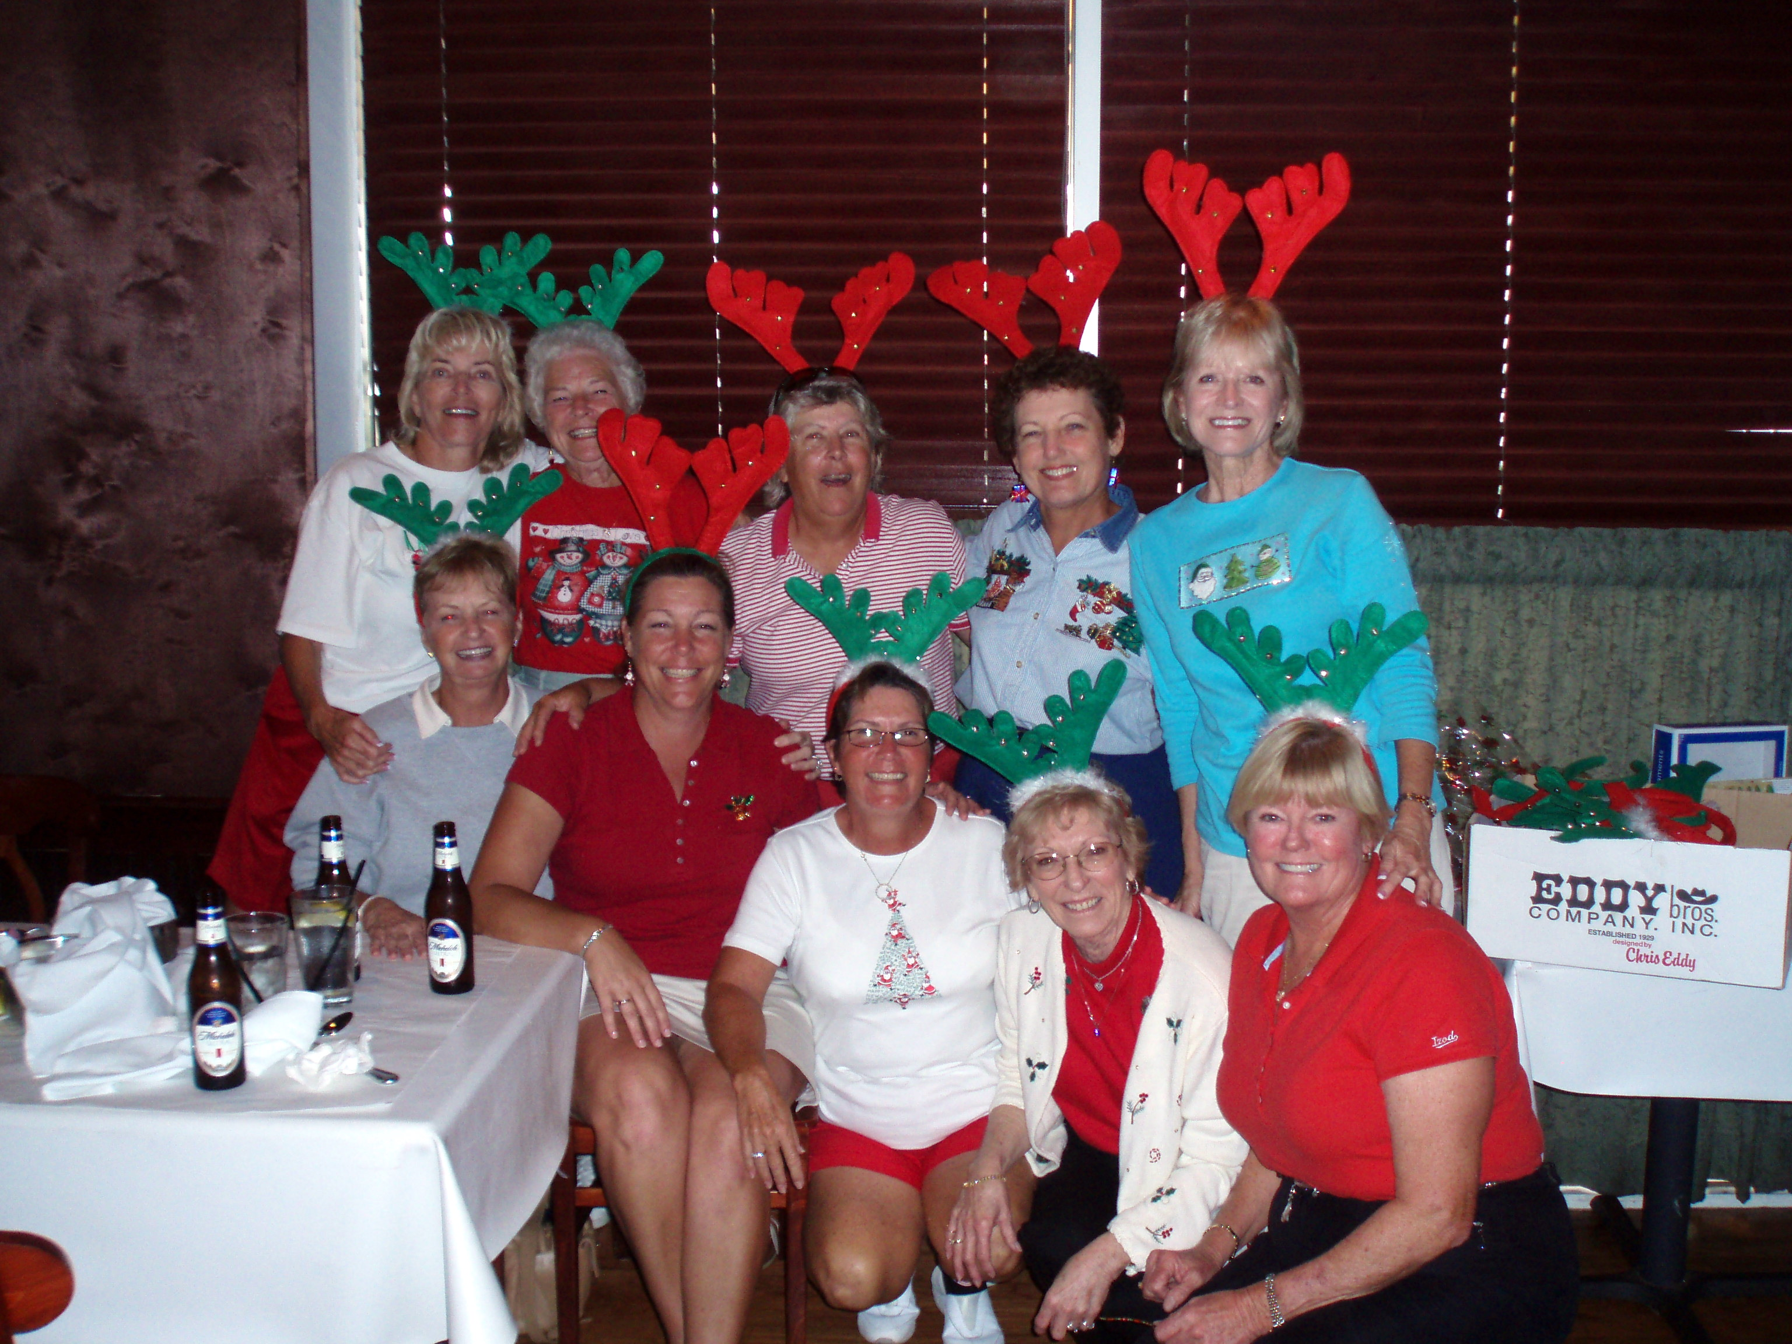
Northdale Golf & CC Ladies Association

“I was never a great athlete, but at that moment, no one was better.”

She watched as her tee shot landed in front of the green, rolled toward the flag and dropped gently into the hole. It was what every golfer dreams of; a ‘hole in one’. Her mind struggled with the reality of what just happened. A 38-handicap golfer, who did not have the length off the tee to reach many Par 3s, had made a hole-in-one.

“All I could think about was that I wouldn’t need to putt,” Rosann said later.

I’m an Artist:

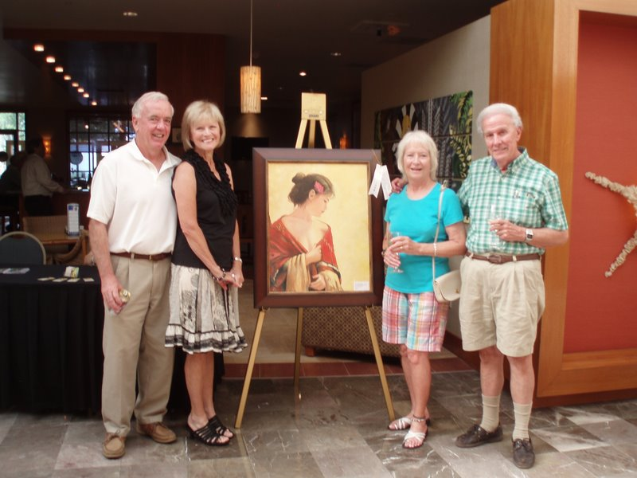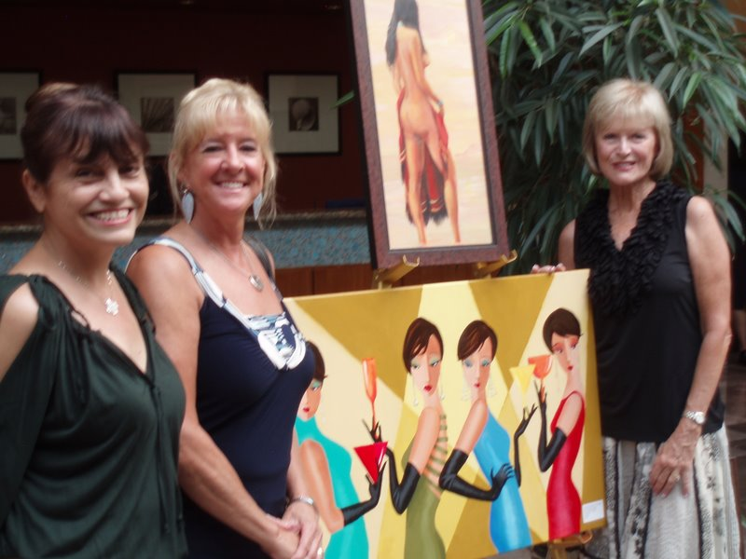

“This was the pinnacle of my art career; my own show. It wasn’t a New York gallery or even a weekend show at a Tampa gallery. It was just four hours in a hotel lobby in West Tampa, but it was MY show. It was my 20 canvases. It was my reputation on the line. I’ve sold a few paintings and have a website where visitors can view my work (www.expressionsinart.net). But this was the first time I’ve been ‘on display’. It’s like opening yourself up and allowing strangers to see inside you. This was a big deal for me.”

Jim and Brenda helped set up the paintings in the hotel lobby. People were already there when we arrived. The hotel provided most of the easels and offered $1.00 drinks and free hor’ derves.

“I was scared. It was hard for me to say; here I am, these are my paintings, take it or leave it. I’m so thankful for my friends that attended and for Jim and Brenda’s help in setting up. I’m so glad I did it.”

The show was a huge success. She didn’t sell any paintings but people liked her work. Most important, it made Rosann a stronger person. This is what Rosann’s friends said about her show.

Joy Ickes: “I went to Rosann’s art show. She had many of her beautiful paintings surrounding her. She worked the room like she owned it. She was such a gracious hostess, made everyone feel welcome and special. She has that knack with people. I was ready to buy, LOL. We also painted wine glasses together one time. I enjoyed the one on one time with her. She inspires me with her limitless creativity. Rosann is an amazing woman whether she is painting, golfing or just sitting and sipping win. I am truly thankful we ended up in that Wednesday art class together.”

Joan Hofmann: “I had done the same show as Rosann a few weeks before she did, so I knew exactly the emotions she was experiencing. I am always in awe of Rosann’s talent. Her paintings are so vivid, full of life and expression. Every time I see them, I am amazed by her talent and the beautiful work that she creates. Her style, color and expressions give me such joy to be able have her for a friend all these years and to have the pleasure of looking at the art that she creates.”

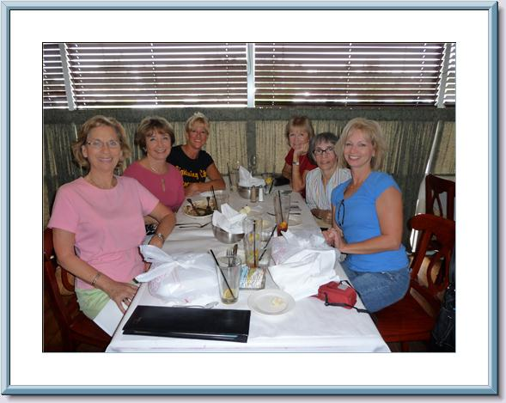

“Wednesday art class, from 11 AM to 1 PM, has been a highlight of my life for the last few years. There are 8-10 other ‘students’ in the class - many of them are very good and have sold many paintings. We have so much fun. I went to my first class since my operation last week and am going again today (4/27). My vision is not good so I’m changing from realism to abstract paintings, from Edwin Hopper to Kandinsky. My ‘class mates’ have been so supportive since my surgery. I’m so grateful to them.”

I’m a Business Woman:

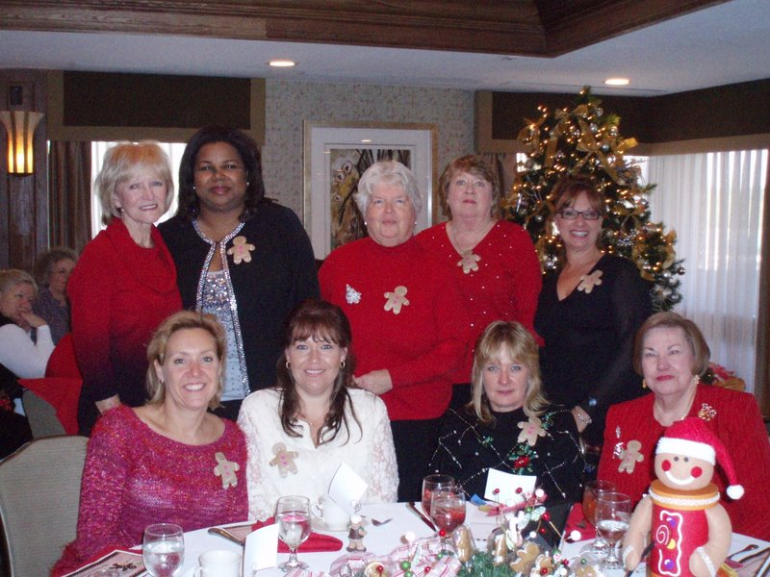
Beta Sigma Phi Business Sorority
North Tampa Chapter

“Jim and I have two businesses. Jim handles Greenman Funding which brokers commercial mortgages and project financing. I was in charge of Gemco Leasing which offers equipment leasing to businesses. Not anymore, Jim’s now on his own. I’m just looking forward to getting back with my friends at Beta Sigma Phi.”

Jim: “We made a good team. I would bring in the business and Rosann would take it from there. She was also invaluable in developing and maintaining contacts for marketing campaigns. Business has been slow the last few years so maybe it was time to retire anyway. I’ll miss her most when we try to develop new business. That can wait; we have a lot going on right now.”

I’m a Biker (bicycles only):

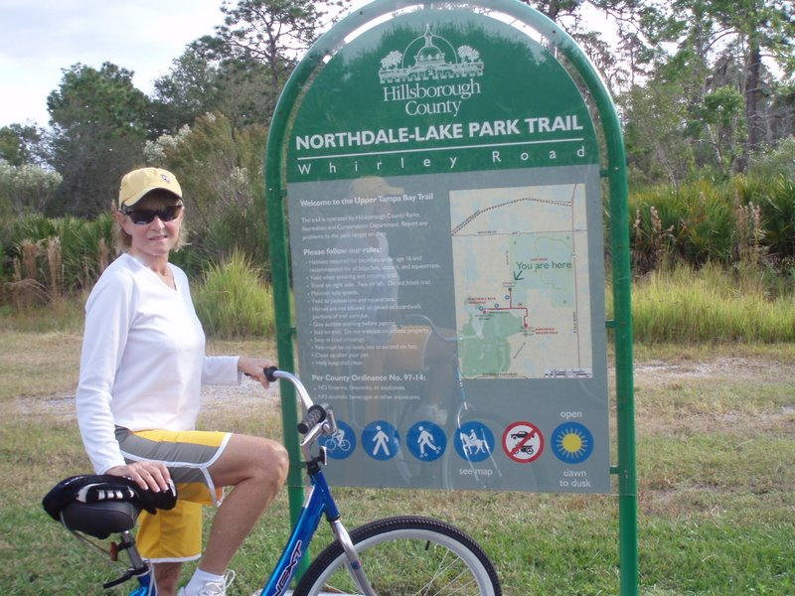

“Five years ago I was afraid to ride a bicycle. In fact, I couldn’t ride a bicycle more than a few feet without crashing. I had forgotten how and it made me feel old. I hate that feeling.
I learned how to ride again thanks to Jim’s help, and patience. It’s I can’t ride anymore, I’m still too weak from the surgery and radiation. The long term problem is my lack of vision. Unless my vision improves dramatically, which is unlikely, I won’t be able to ride again. That hurts.
We are looking at ‘tandem bikes’ as a way to get out and enjoy the weather and the fragrances. I couldn’t see much but Jim would be my eyes and jog our memories. I need to get a little stronger before we try. I’m afraid I might get dizzy and fall off. Riding again would be nice for me and also for Jim. It would make me so happy if I can do that for him.”

Jim: “Riding a bike doesn’t seem like much, but conquering this seemingly simple task made Rosann feel about herself. It was beautiful to see. Riding was also a lot of fun. A friend suggested a dual recumbent bike or maybe a three-wheeler; I’m looking into that. It’s very sad to ride our bike trail without Rosann.”

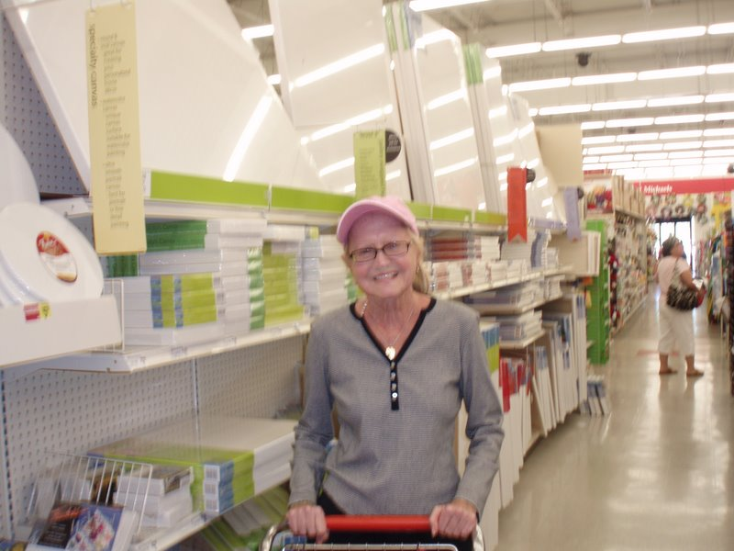
Rosann Today, May 2, 2011

“All-in-all, I think I’m doing all right. I’m going to start playing the piano again soon. It’s hard because I play from written music, not from memory. Who knows, maybe I’ll even get Jim to take me dancing again. Sometimes when we are walking for exercise he will hold me and twirl me as if we were slow dancing. We also jitterbug a little. He says these are exercises to help me regain my balance and coordination but I know it’s dancing. A girl can hope.”

Chapter 3
Subtle Warnings

“Should I have seen this coming? I don’t think so. There were a few subtle hints, but nothing that got my attention. I hadn’t felt 100% for several weeks, but nothing that I could put my finger on. I’ve always had poor eye sight due to a detached retina in my right eye. Cataract surgery in 2010 helped a little, but I still relied almost entirely on my left eye for vision. My optometrist recently gave me a stronger prescription for my contacts which helped a little. My eyesight still wasn’t great but I was living an active and normal life. Everything was good.”

50th High School Reunion - March 4, 2011

“Friday was my 50th Notre Dame High School reunion. I had been looking forward to this for several months. I dreaded driving and fortunately had arranged for two friends to drive. It’s an all-girls school and husbands weren’t invited. Marge and Mary picked me up home and drove downtown to Kemoll’s Top of the Met Restaurant. The restaurant and food were great and I had a great time seeing old friends. I had a little problem keeping the Salmon on my fork, but nothing anybody else noticed. I was home by 10:30 PM.”

These are some comments from Rosann’s high school classmates;

Marge: I have spent a lot of time rehashing Friday night since all this has happened. We talked on the phone early in the week and, you were very enthusiastic and excited about the reunion. You did not mention feeling poorly and you sounded great. Friday night it was pouring rain when Marci and I picked you up. I was really impressed with how wonderful you looked. We chatted all the way to Kemoll’s. You mentioned that your vision was not quite right and we then started talking about your eye surgery you had shortly after graduation. We visited with lots of people and even went in different direction for a bit. You ordered a glass of wine but drank very little of it. You had a slight headache and didn't know if you should be drinking. That was the first indication that anything was unusual. You did not eat much of your meal but did say it was excellent food. When it came time for the picture, we had only a half of chair to sit on and your balance was good. Fight, fight, fight and know that we are pulling and praying for you.”

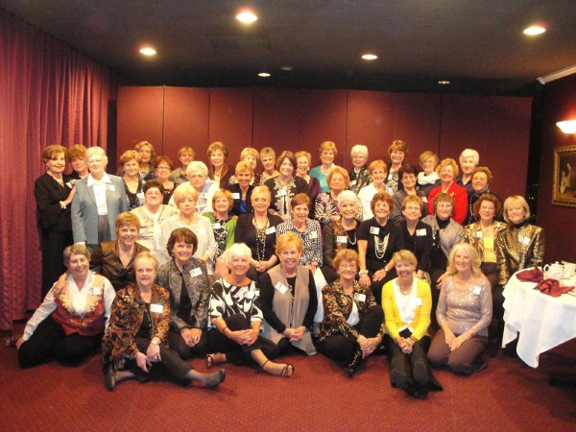
Notre Dame H.S. - Class of '61 (Rosann is 2nd row, far right)

Millie: “I didn’t notice anything wrong that Friday night – I remember making the comment how great you looked, and how I was going to visit your website. But you looked happy, healthy and beautiful as always. Hang in there my friend; you are on many prayer list, and always in our hearts. Love.”

Chapter 4
March 5, 2011
The Day My Life Changed

Saturday, March 5, 2011. “Linda drove my mother and me to the 12 PM funeral service at Assumption Church in O’Fallon, Missouri, about 35 miles from Affton where I grew up and my mother still lives. The weather was nasty, especially for a Floridian. I remember being unusually cold as we walked into the church. The funeral mass was for the paternal grandfather of my daughter’s oldest children, Kyle and Cassie. We offered out sympathies to Rita and to Kyle and Cassie. We took our seats towards the rear of the church.
Ten minutes later the headache began. It was the granddaddy of all migraines. The pain was unbearable. My mother asked me if I was okay but I couldn’t respond. I’m told that Kyle’s girlfriend and her mother saw I was in distress and her mother and my sister helped me to a bench at the back of the church. I was still in pain and Allie’s mother called 9-11. I remember feeling bad that I was disrupting the church service.”

Helen Folk (Mother): “Rosann seemed normal that morning. Linda drove us to the church and Rosann was chatting away like sisters. The first sign something was wrong was when I saw her holding her head and grimacing. I could tell she was in pain.”

“I don’t remember much after that. I knew I was in an ambulance and felt sick to my stomach. I had no recollection of being transferred to a second hospital. People kept asking me my date of birth. I kept telling them but the next person would ask me the same question. I told them again. The rest of the day was a drug-induced blur. Someone else will need to tell what happened.”

Chapter 5
ICU
Sunday and Monday

Recovery:

“I knew I was in a hospital but didn’t really care why. I’m sure someone told me I had an operation but I don’t recall anything about the previous day. I remember being in church for the funeral service and talking to Kyle and Cassie and vaguely being in an ambulance. I don’t remember anything after that. I’m sorry, I’m not much help.”

Dr. Martin stopped by and later said he was pleasantly surprised. Rosann was doing better than expected.

Nurses and doctors came and went. Dr. Vickers, Dr. Meier, Dr. Garcia and the nurses and techs that needed to draw blood or give her medication. They all asked the same question; ‘Do you know your date of birth’? Relatives were shuttled in when Rosann was awake and time permitted. Mother, sister, sister’s husband, niece and others waited for an opportunity to visit with Rosann.

Mother: “I was surprised she looked as good as she did. She was a little groggy but was able to talk with us.”

“I knew my Mother and Sister were in the room but I was so tired that I kept on drifting off. I kind of remember talking on the phone with Jim but don’t remember what he said. The drugs were in control.”

Rosann’s condition improved and Monday afternoon she was transferred from Intensive Care to a monitored care unit and a new set of nurses and technicians.

Chapter 6
Hospital Highlights
The next Eight Days

“I can’t come close to telling you what happened day by day, but I can tell you what I remember most.”

My awesome support group!

“I was 900 miles from home, but never felt alone. My mother and sister, Linda, were at the hospital continually along with my niece, Nicole and various other relatives. They must have set a record for visitation hours. Flowers were everywhere and nurses continually told me how beautiful they were. I couldn’t see well enough to appreciate them fully, but it meant a lot to me. Thank you. Every day someone would read me the cards that came that day from relatives, golf friends, my Tampa art group, Notre Dame Classmates and just plain friends. It meant so much to me that all these people cared about me and were praying for me.
Evenings and weekends were filled with visits from friends and relatives. My son in law, Dave Jalil, brought my younger grandchildren, Lauren and Emma. Kyle, the oldest, brought his girlfriend, Allie and a single flower. Allie’s mother was the one that sat behind us at church and called 9-11. Cassie, a freshman at the University of Missouri, came home on the weekend to see me. I’m so proud of these kids. I wish their mother, Dawn, was alive to see how wonderful her kids have turned out.

Chapter 6
Fighting Back -The first 45 Days

“Joy lies in the fight, in the attempt, in the suffering involved, not in the victory itself” - Mahatma Gandhi (Indian Philosopher)

Rosann’s battle was fought on several fronts.

Humana Gold Plus - the role of the PCP

Everything goes through the ‘Primary Care Physician’ under the Humana Gold Plus plan. Rosann’s PCP is Dr. Daniel Heinig M.D., who is also serves as a member of the board of directors of Gulfside Regional Hospice.

Tampa is blessed by having a great cancer research hospital; H. Lee Moffitt Cancer Center & Research Institute. It is world renowned and has an excellent reputation; deservedly so. Rosann’s family just assumed she would be treated at Moffitt. Her friends in Tampa told stories of the wonderful treatment their friends and associates received at Moffitt.
Moffitt is also part of the Humana insurance network which means nothing unless the PCP refers you to a Moffitt doctor. Rosann’s PCP did not. Moffitt was not part of the group of the small group of doctors that he dealt with.

Rosann met with Dr. Heinig Thursday morning. He had already made appointments for Rosann to see a Janelle Park M.D., a radiation oncologist Friday morning and Pedro Mendez M.D., a medical oncologist Monday. Early in the conversation Dr. Heinig asked Rosann if he could speak frankly. Rosann nodded yes. It was a mistake. He should have asked if he could be ‘brutally frank’.

Rosann: “He asked me if he could be frank with me and I nodded yes. He then proceeded to tell me that I was going to die and asked if I wanted him to make an appointment with a hospice group. I couldn’t believe what I was hearing. I know the graveness of my situation, but I was looking for treatment. Encouragement would have been more important at this point than realism. I wanted to fight this battle, not plan my death. It was too soon for that.”

Radiation Oncologist Treatments: Tampa Bay Cancer Center, Janelle Park, M.D.

“My five-week experience with Dr. Park and the nurses, staff and technicians at the Tampa Bay Cancer Center has been a totally pleasant experience. I can’t thank them enough for their help and love.”

Dr. Janelle Park: “Mrs. Plautz is a true trooper. She came to the clinic for her initial consultation, and was determined and ready to do whatever she needed to do. We discussed the use of CyberKnife versus whole brain radiation therapy upfront; due to the fact that she had had a bleed in the brain that was, in light of the final pathology, related to a metastatic lesion, I felt that there was a high risk for additional tumor cells to be within the intracranial space. These would not be addressed if we started with CyberKnife first; thus we opted to go with whole brain radiation treatments first, and re-evaluate after completion of the whole brain radiation for potential CyberKnife boost to any residual disease.

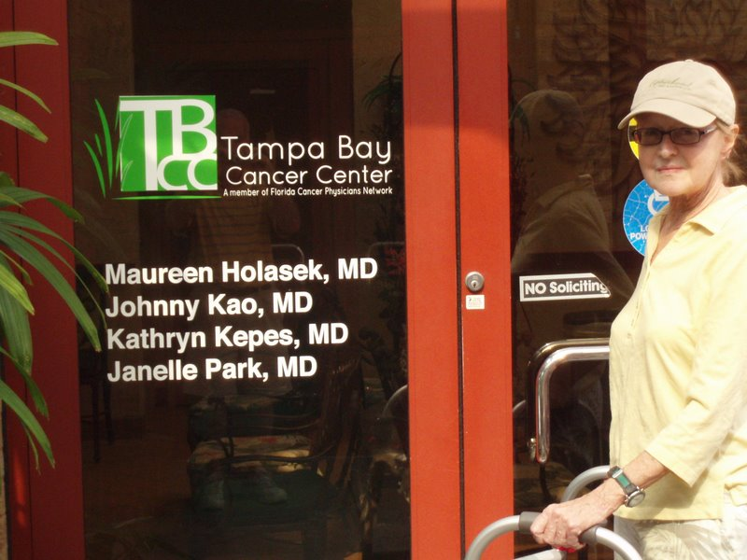
One of 4 TBCC Offices - Tampa

Chemotherapy - The Mendez Fiasco

Rosann and Jim eagerly awaited their second appointment with their Medical Oncologist, Dr. Pedro Mendez - M.D. They were eager to begin treatment for the lung cancer which had already spread to the brain. The PET Scan results were good news, the cancer had not spread to other organs. Rosann cried for happiness when the Radiation Oncology Nurse told her the good news. There was a small glow at the GE Junction, but it could be a lymph node or something else that was non-cancerous. It was not a major concern.
Dr. Mendez walked into the appointment room and began reading the file. It was obviously the first time he had seen the PET Scan. After telling Rosann that she looked a lot better than she did at their first appointment, he sat back and said to Rosann; “We have only one question here. Do you want me to give you chemotherapy?”
Rosann and Jim were silent for a few seconds before Rosann replied; “You are the expert. What do you recommend?
“The only question we have today is whether you want chemo or not. I’ll give it to you if you want me to.”

Church - the daughter factor

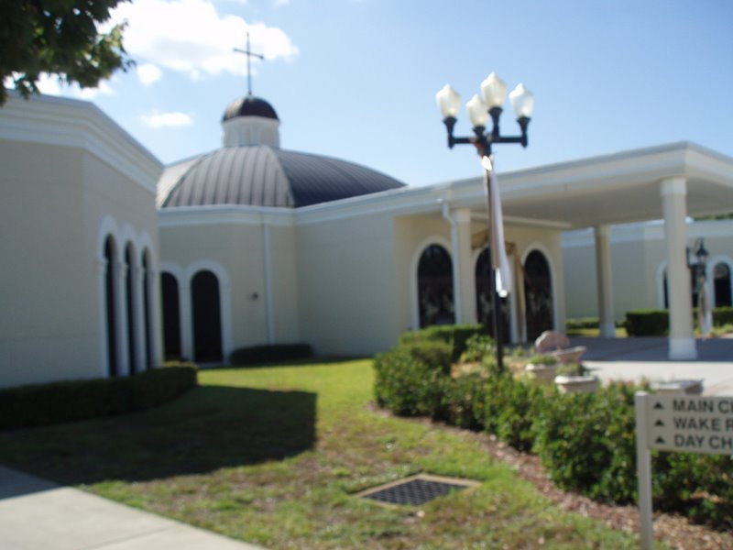
St. Timothy Catholic Church, Lutz, Fl

Rosann is Roman Catholic. Rosann and Jim, also a Roman Catholic, were married in a private ceremony but remained Catholics and attended church semi-regularly. That changed when her daughter, Dawn, died of breast cancer at the age of 38, leaving four young children without a mother. It also left Rosann without a daughter and the loss was devastating. She thinks about Dawn every day and asks, why. Why take a good person so young? Rosann didn’t get the answers she sought and gradually drifted away from the Church.

“I was bitter. Dawn was such a great mother and a great person, it just wasn’t fair.”

Five years after her daughter Rosann is faced with many of the challenges that her daughter faced. Her daughter fought off the breast Cancer for almost five years. Rosann wants to do the same with her lung cancer.

SSM St. Josephs Health Center is a Catholic Hospital.

Jim: “I flagged down a Catholic priest a few days after the operation and asked if he would stop and see Rosann. I told the Priest a little bit of the story and suggested Rosann might offer some resistance. She didn’t and Rosann’s religious turnaround began.”
Chapter Seven
Who I Am

“I’m much more than a golfer, an artist and cook. Like most women, I wear many hats.”

I’m a Woman:

“I’m proud of the way I look. Does that make me a vain person? I don’t think so. It does mean that I’ve spend a lot of money on clothes and look forward to my weekly nail and hair appointments when I can afford them and biweekly, or less, when I can’t. Am I the only woman that spends a little money to make ‘me’ feel good? I don’t think so.
Yes, I have too many shoes and dresses that have been worn only once. Some of the once worn clothes in my closet I wore to my 50th high school reunion. Tell me it wasn’t worth it. I felt good and I felt attractive. Several women, Notre Dame is an all girls school, complimented me on my looks. It was worth it!

I’m a Friend:

Rosann is blessed with many friends, many of whom have contributed their feelings in this book. We asked a few to tell us what makes Rosann special.

Tom & Pat Oswald: “I don’t think I’ve ever met a “Southern Belle”, but you are who I imagine – Gracious, Generous, and Lovely. I love talking about cats with you and watching you with them. The pleasure you exhibit is contagious. Tom and I are pleased to be your friend, Pat.”

Claudia Perry, a.k.a., Des: “Rosann is my best friend, my dearest friend, the sister of my soul. We can go months without talking, and pick up on the next sentence when we see each other again. She has that extra special something that makes people turn their heads when she walks into a room. When she's feeling down or insecure, I remind her that she's "Rosann"...meaning there's no one else quite like her in the world. She's a classy lady with bright blue eyes that sparkle with love and mirth. Yet she can be a wild and crazy friend. We like to laugh at that greeting card that says: "A good friend will come bail you out of jail, but a true friend will be sitting next to you saying...'Damn, that was fun!'" We've seen each other through the best of times and the worst of times. You only have one best friend...and she's mine. I love you, Ro”

I’m a Mother

Rosann and Gordon were blessed with two great children, Dawn and Dave. Dawn was a RN and mother of four. She passed away in 2004 at the age of 38 after a 4-year fight with breast cancer. Rosann took it very hard. Dave is a people person, like his mother. He has held various jobs in the service industry including restaurant manager and head gold pro. He has one son, Corbin (19).

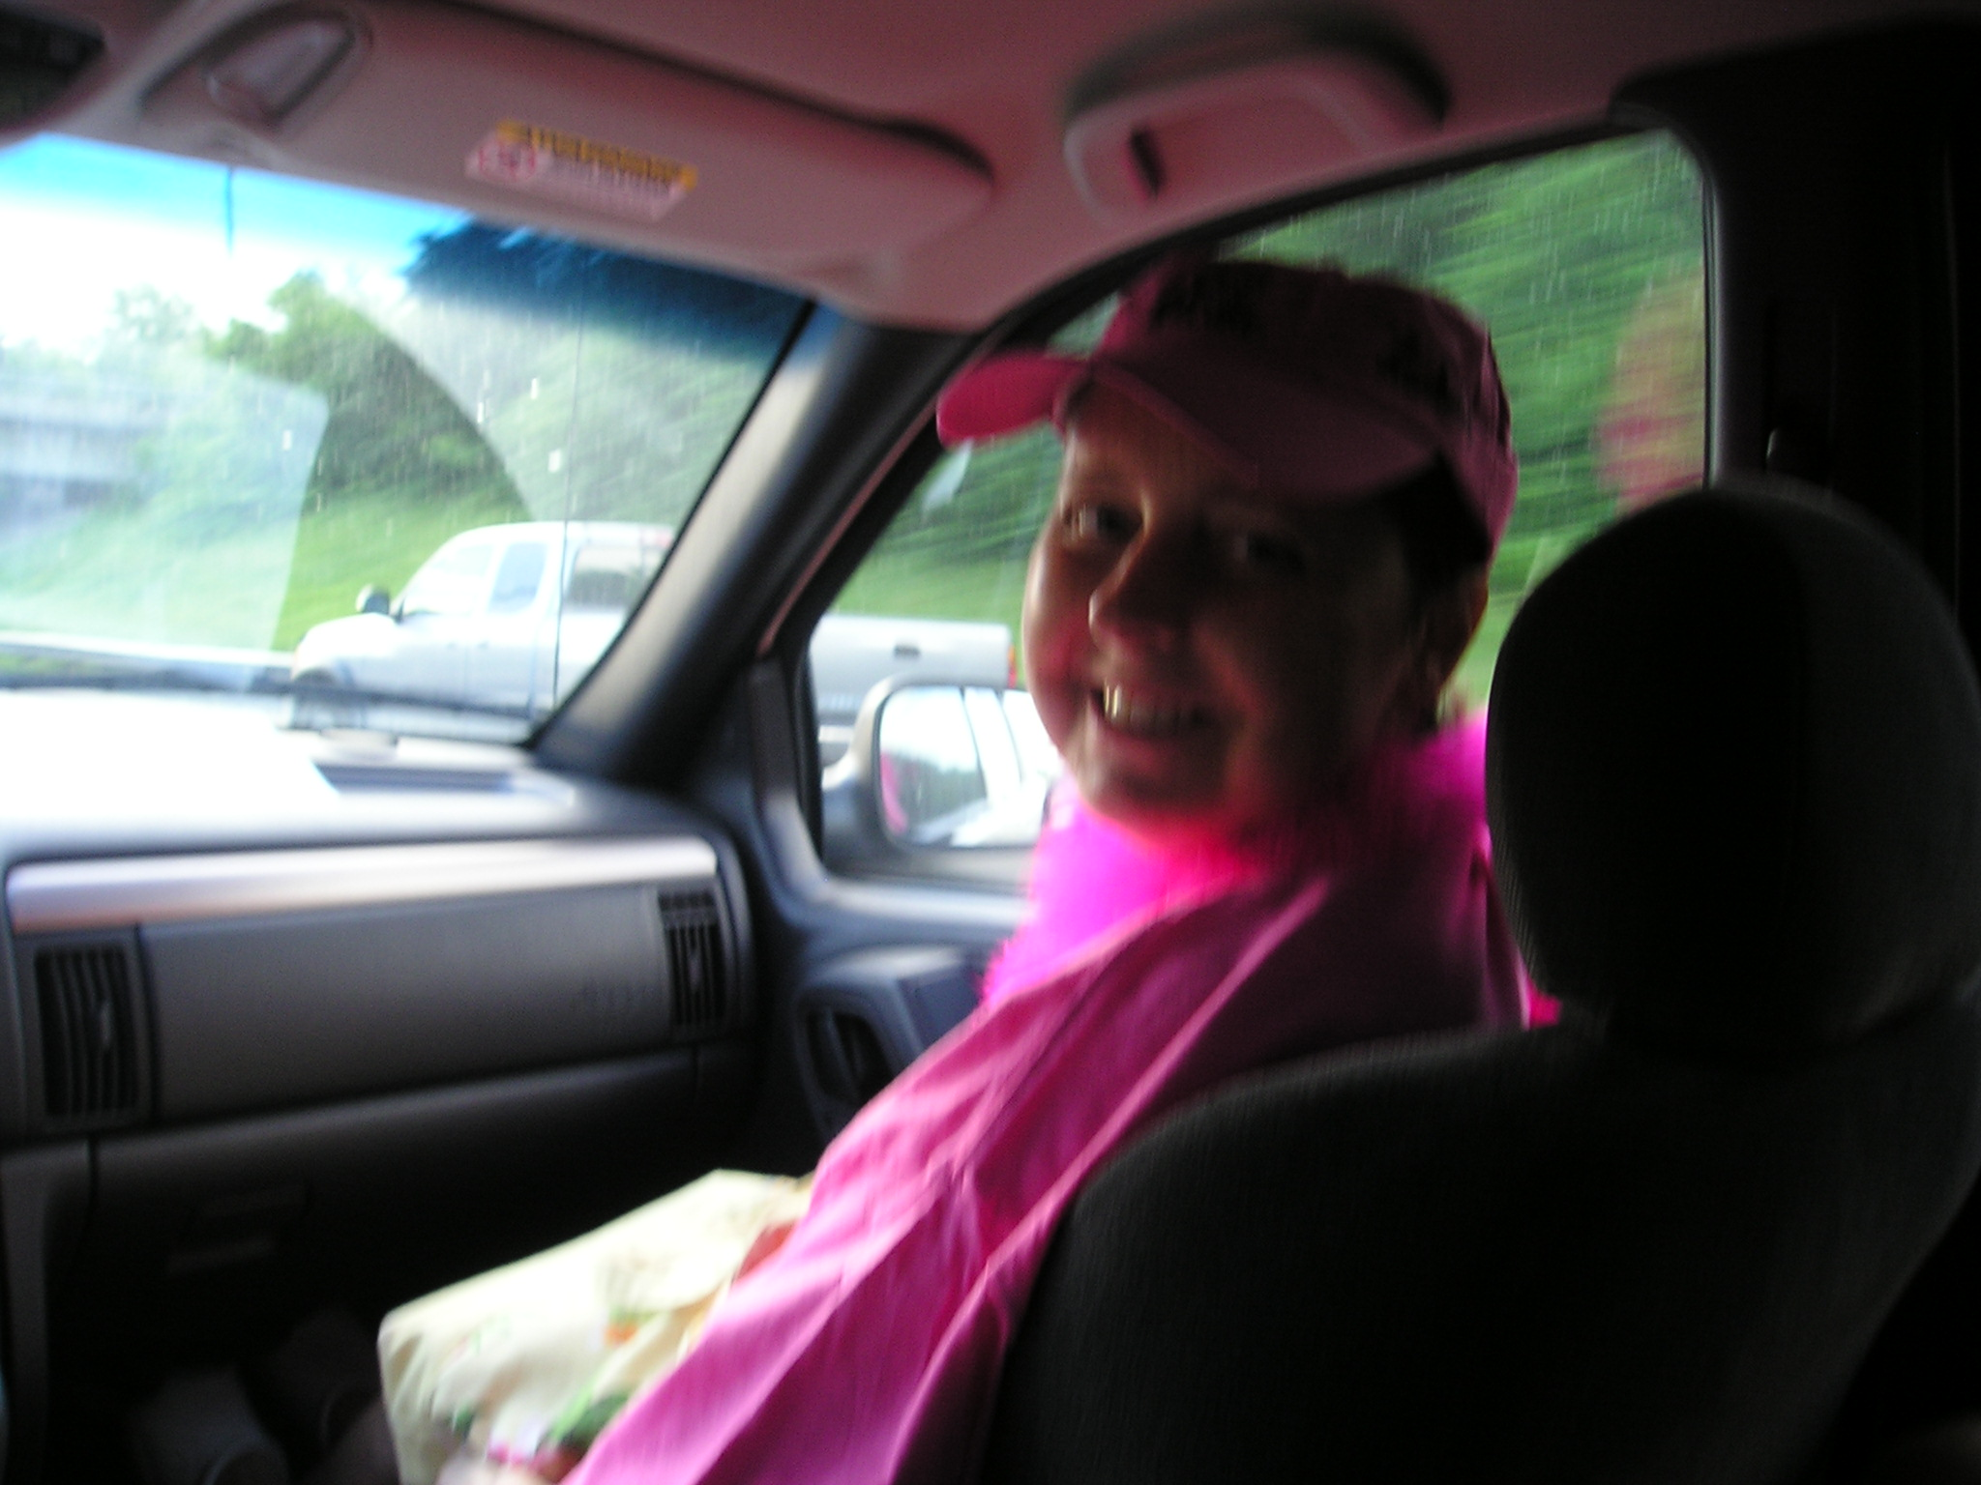 “I have never gotten over losing Dawn. I think of her every day and admire the way she fought off breast cancer for so many years while being a mother to four young children, wife, and nurse. She had a great sense of humor and many, many friends. Dawn, you are my hero. I miss you so much. It’s not fair that you did not get to see how well your four kids turned out.”

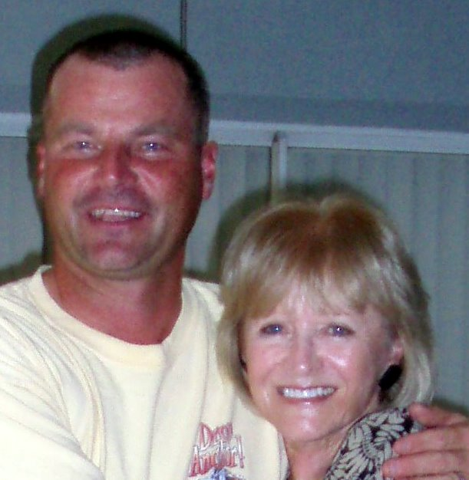 Dave is my pride and joy - always has been. We have always been extremely close and continue to provide support to each other. It was so much fun watching his soccer games and meeting his friends. I remember what he said when I asked him if he was okay with Jim and me getting married. “Mom, I want whatever is best for you. Just remember, if something should happen, I’ll take care of you.’ I have a big place for Dave in my heart and a place for him in my home if he ever needs me. I am so proud of him. He’s more than a mother could wish for. I’m so lucky.”

Dave Glandt - My Mom: “Every son will say that their mother is the best, but I'm sure others would agree that my mom is truly the best. She has always been there for me, from the first memories I have as a child, to this very day. She managed to work a full time job, cook dinner every night, and always was there for what seemed like endless sporting events I was participating in. I can still hear her cheering me on at the indoor soccer arena, knowing I had 1 or 2 more games that day, and being there for all of them. Being a catcher playing baseball, the fans, really the parents, were close to me behind the backstop. As grown up as I tried to be at 13 or 14, turning around and seeing my mom in the stands, cheering me on, even getting kicked out of a game arguing for her son, was the best feeling in the world. I could never understand the kids who didn't want their parents around with their friends, because my mom was the coolest, I always wanted her there to share my triumphs, and my not so triumphs.

I’m a Step Mom & G-Ma to the Plautz Kids and Grand-kids

Jim has three children in his first marriage and seven grand children. Bill lives in Seattle with his wife Kate and their three children; Ella (6), Coco (4) and James (1+). Mike and his wife Claire live in Virginia with Cassidy (6) and the 4-year old twins, Luke and Logan. Kelly, the youngest, and Brandon just had their first child, Maddie (6 months). They live in Atlanta. It’s Rosann who keeps track of birthdays and sends the appropriate gifts.

Rosann: “I love Jim’s kids and spouses. They have always made me feel like I was part of their families. The children all have their own personalities. It’s so much fun to watch them grow.”

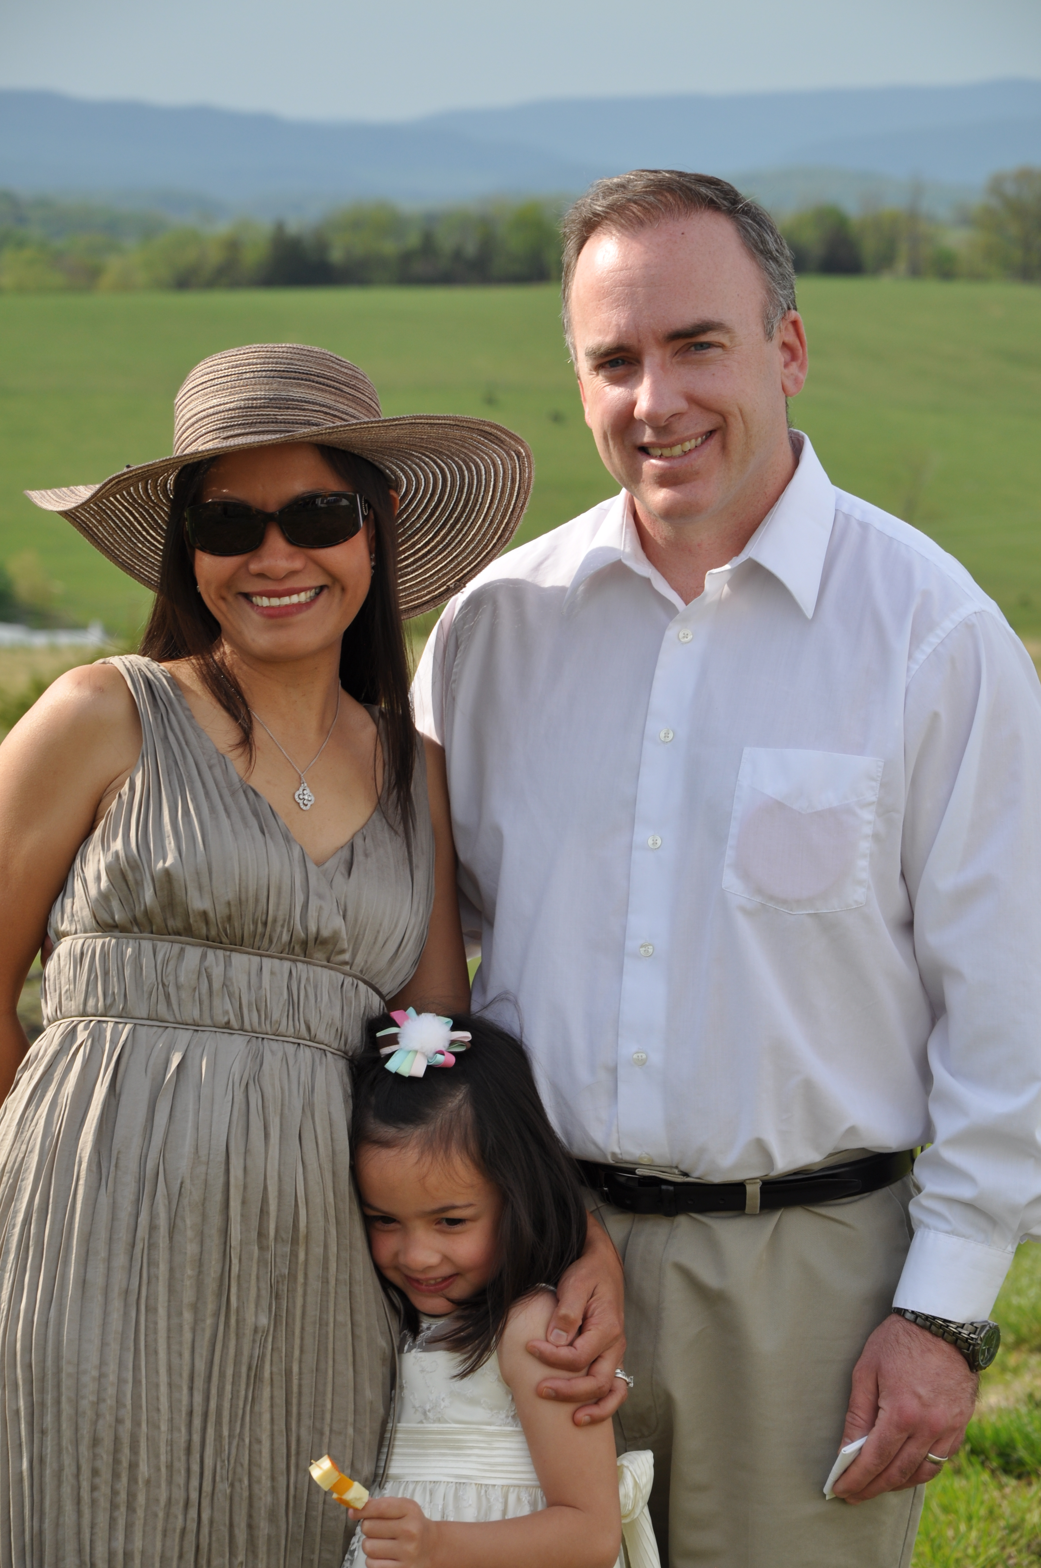 Mike and Clair: “Rosann always puts others first. She has always been sensitive to others' feelings and the first to say thank you for anything. She seems to put herself in the other person's place effortlessly and has never uttered a negative comment about someone else in the ten-plus years I've known her. All of the memories I have of her have these things in common.“We are very, very lucky to have grandparents who shower our kids with so much love (and gifts, clothes, toys and time).”

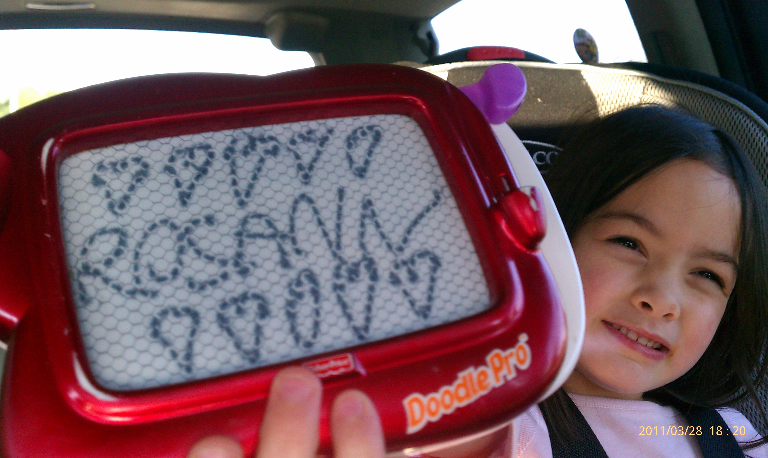 Cassidy (51/2) has Grandma Rosann's love of art and eye for color. She loves to draw, paint, create and has boundless imagination. Cassidy just beamed when she opened the box of art supplies Gma Rosann and Gpa Jim sent on her birthday (Gpa got credit, but we know who the real mastermind was behind that). We see Gma Rosann in all of Cassidy's paintings and drawings that decorate our walls, and Cass is looking forward to someday having personal lessons from the pro.

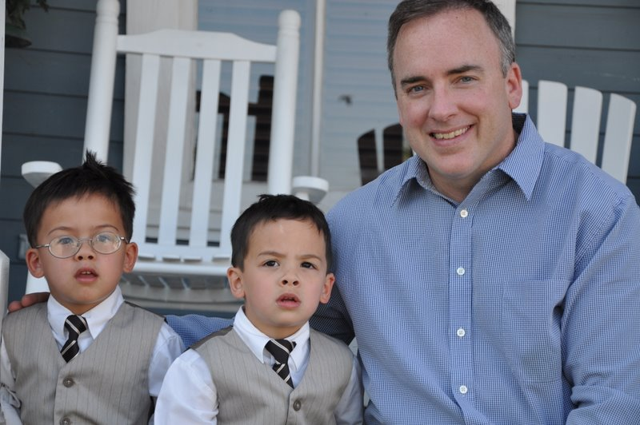 Twins Logan and Luke (4 yrs) remember Grandma Rosann's kindness and patience with them. They push EVERYONE's buttons, but cannot seem to find that button with Gma Rosann. Logan remembers running around the Veritas winery while Gma chased him around. He didn't have his glasses yet then, so he was pretty easy to find.

Luke remembers the luau at Disneyworld with both Gma and Gpa, watching fireworks and dancing on the beach afterwards. He enjoyed riding the monorail on Grandma's lap, even though he tried to escape a few times. He is sorry for climbing on Gma's chest and shoulders while trying to swing from the handrails on the ceiling (although I am pretty sure he will try that again, if given the chance).”

“These are only a few of so many fond memories. Mommy Claire remembers Jim and Rosann's wedding in Tampa, fashioning bouquets and the altar on Thanksgiving Day; fun times on the Caribbean cruise and lounging on the beach in Puerto Rico; enjoying dinner in Staunton while talking about family. Our family has been so blessed to have had this time already and we can't wait to make more fun memories with Grandma Rosann.
We love you, Grandma. Your warmth and kindness, family values and vibrant love for life are all forever present in us and our children and will never go away. Keep fighting; we are all fighting with you. See you soon!”
Love; Claire, Mike, Cassidy, Logan and Luke.

I’m a Wife

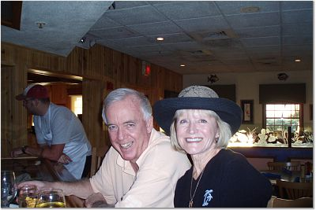

“Jim opened a whole new world for me and allowed me to grow as a person. He knew I loved to play the piano so he bought me a baby grand. He encouraged me to get back into art and take lessons. We joined a golf club and went on many great golf vacations. We traveled to Costa Rica, the Caribbean, Rome, Istanbul, Constantinople, Paris, Nice, Venus, Monte Carlo; places I never thought I would ever see. Traveling truly does broaden a person’s perspective. I can never thank him enough. But mostly, he has been there for me. We share so many things.

Chapter 9
Today, May 2, 2011
Taking Inventory

“This book isn’t about winning or losing, it’s about how I play the game. It’s playing the cards that I was dealt. I’m winning this battle, one day at a time. What else can I do, give up? This is where I stand as of May 2, 2011.”

I’m Proud of my accomplishments:

There have been a few disappointments:

- My eyesight has not improved, this makes everything more difficult;
- Its been almost two months and treatment for the cancer in my lung have not begun.

My Health is good, considering…

- I’m not in any pain, no more than most women over 50;
- The PET Scan showed no spread of cancer to other organs, other than the brain;

I’m looking forward to the following medical procedures:

- A clean MRI showing the brain tumors are gone;
- CyberKnife radiation on any remaining tumors in the brain, if necessary;
- A Chemo doctor that cares and provides me with a plan that gives me a chance to Fight Back.

Personally, I’m looking forward to Victory;

Author’s Note

What’s Next?

This books covers the 58 days from March 5, 2011 through Monday, May 2, 2011. We planned on ‘cutting off’ the book when “treatment” began but circumstances caused chemo treatment to be delayed. The message is the same; Rosann is still Fighting Back and optimistic that the chemo treatments, and possibly radiation treatments on the lung, will stop or delay the spread of cancer.

